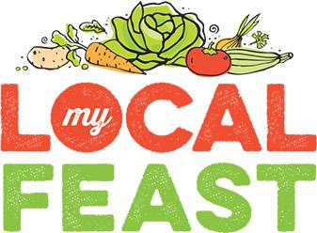

MEDIA RELEASE
1 August 2016

Forum to focus on regional community food hub
The potential of establishing a regional community food hub will be the focus of the My Local Feast – Toowoomba Food Forum being held at the Armitage Centre, Toowoomba on Thursday, 11 August from 9.30am.
The forum is part of an inaugural national food hubs speaking tour featuring international authorities Anthony Flaccavento from SCALE (Sequestering Carbon, Accelerating Local Economies) in the United States and Kathryn Scharf from Community Food Centres, Canada.
The forum will also feature local food producers telling their stories and the opportunity for discussion from the floor with a Local Food Tourism Panel and a Food Hubs and Economic Development Panel.
My Local Feast founder Josie Townsend describes the forum as a rare opportunity for local food industry representatives to come together and discuss the very real potential of having a regional community food hub.
She said the forum would explore the benefits, opportunities and challenges of establishing and operating community food hubs while showcasing various approaches currently being used in developing food hubs.
“There are many different forms of community food hubs and they serve diverse social and economic purposes such as food enterprise development, enhanced health and wellbeing, increased net regional product, expanded employment and training opportunities and increased environmental sustainability.
“The potential benefits of having a local community food hub in this region are huge. Closer collaboration between producers, manufacturers, retailers, restaurateurs and government can only mean stronger representation, advocacy and lobbying power.
“We hope this forum will help identify the types of partnerships, skills, funding and financing possibilities, infrastructure, experience and capacity, and governance options needed to set up a community food hub. It is for growers, manufacturers, consumers, retailers, government and industry, food hubs are all about involving everyone,” Ms Townsend said.

Forum attendees can attend the Empire Theatres farmers market at the conclusion of the forum.
Tickets to the forum cost $110 per person or $100 each for groups of 10 or more. Please see www.facebook.com/toowoombafoodforum/ or http://www.mylocalfeastfarmersmarkets.com.au/food-forum.html for more information, to find more information or to purchase tickets.

-ENDS -

For further information, please contact Jenny Foxton on 0439 979 202

